**The eye-gaze revolution**

**Eye-gaze has come of age in a way many of us could have only dreamt of**

***By Sandra Thistlethwaite***

I first became interested in eye-gaze when, as a newly qualified speech and language therapist, I met six-year-old David. David had quadriplegic spastic cerebral palsy. He was the first child I met who couldn’t talk at all, could hardly move, yet had that special glint in his eye that, to my mind at least, said he had things he wanted to say.

We had very little technology to work with in those days. We had a BBC computer and raised funds for a speech synthesiser so that we could have sound. We struggled to find motivating things that David could do because for him access was so difficult. Over his school career we probably tried every type and position of switch imaginable, but nothing worked well enough to be useful on a day-to-day basis. Our saving grace was the low-tech eye gaze system we developed over time.



David’s low-tech eye-gaze book – known as ‘The Bible’ to his family

Great, but for it to work well David still needed willing and able communication partners with lots of time and personal knowledge of him. If only there was a device that could read his eyes…

After 12 years of working together, David and I went our separate ways: I, to work for the ACE Centre and David to a specialist college. In my new job, I attended a clinical engineers’ conference and got my first glimpse of eye-gaze technology: a large alphabet board accessed using the eyes. The results were amazing, but so too was the price: £14,000. Even so, I was hooked on this new technology and keen to see how it would evolve. A few years later I heard of Tobii and the P10, a dedicated eye-gaze computer. Wow! You could use your eyes to move the cursor and spell out your name! The revolution had begun.

When I joined Inclusive Technology in 2007, I had many more opportunities to try this new eye-gaze system with a range of people. It had clear benefits for many adults I worked with, but drawbacks too: it had to be plugged in, was hard to position and was still very expensive. A couple of years later, and things started to change. By now all the major AAC companies were offering an eye-gaze module or add-on to their dedicated systems. These systems were portable, had long battery lives, loud speakers and suit­able vocabulary — ideal for AAC users who had previously struggled with other forms of access.

*Switch:*



*EyeGaze:*



Declan practised using a switch for six months and was able to play cause-and-effect and some switch-timing games. Declan then tried eye-gaze for two weeks and was able to play a 28-card memory game

More and more AAC users were finding that eye-gaze could provide a more direct, easier and quicker way to com­munication than other forms of access.

But it wasn’t suitable for everyone. At that time my work involved travelling around the UK visiting teachers, thera­pists and students, all keen to try this new technology. For the ‘straightforward’ cognitively able student with no visual or learning problems, these visits were a breeze. A quick check that the technology worked with their eyes, a discussion on vocabulary packages and a try with a few easy games and grids and it was an easy conclusion (except, of course, for finding the funding).

But there were many visits that were less conclusive. These usually involved students with more complex learn­ing and sensory needs for whom every other access method had been tried without success. One-off visits frequently suggested some potential for using eye-gaze but often the student was insufficiently engaged to leave us certain. I came to the view that one of the main reasons why students did not respond favourably when eye-gaze systems were tried with them was the type and appropriateness of the content or activities on offer. At the time, most of these were grid based, relied on targeting and dwell selection skills, and AAC readiness. Many students I saw:

• Could not, as yet, accurately access a grid of cells with eye-gaze

• Were at an early stage of communication

• Had visual/perceptual and/or cognitive difficulties

• Were not motivated by traditional vocabulary page sets

It was clear these students needed to gain visual skills to use eye-gaze effectively, but just as importantly they needed early learning skills to develop interaction with and even interest in the screen.

Working for Inclusive Technology meant that I could try lots of different software with eye-gaze. I explored how it could be used as a mouse pointer tool. This opened up lots more content that was potentially more relevant to the students I met. Cause-and-effect activities, songs, stories and creative programs were engaging and appropriate, and if they could be used with a mouse they could potentially be used with eye-gaze. If I knew the learning level and motiva­tors for a child, I could choose an appropriate software title, fuelling more engagement and interaction.

I compiled a list:

[How to use myGaze with HelpKidzLearn.](http://www.inclusive.co.uk/Lib/Doc/pubs/eye-gaze-hkl-mygaze.pdf)

[How to use Tobii Eye Gaze with HelpKidzLearn.](http://www.inclusive.co.uk/Lib/Doc/pubs/eye-gaze-hkl-tobii.pdf)

Fantastic if you have access to and an in-depth knowl­edge of a lot of software; trickier if you are a busy teacher or therapist without either. The feedback from my profes­sional colleagues was, ‘This is a great idea, but where do we start? What are the next steps? How do we measure success or progression? Can I justify spending £10,000+ on this child?’ All good questions.

It was in early 2012 that I started researching eye-gaze, visual and learning skills in more depth and developed a prototype software package. I distributed this to interested teachers and therapists and trialled it with a range of stu­dents.

I learnt a great deal from this and a specification for a full software package began to take shape. It was time to talk to my managers about making this idea a reality;

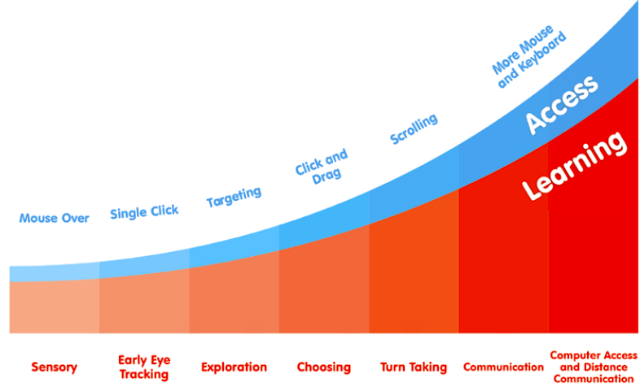

[The Inclusive EyeGaze Learning Curve](http://www.inclusive.co.uk/inclusive-eye-gaze-p6501) – This collection takes children on the learning curve from assessment and cause-and-effect understanding through to using eye-gaze for communication, learning and leisure

Around this time two other important resources entered the marketplace. The launch of the Tobii PC Eye and Sensory Eye-FX helped shape the future of eye-gaze technology. We now had a small, portable eye tracker, which was half the price of previous eye-gaze systems and could be used on any Windows device, and a software pack­age that gave immediate success and feedback to the user while being engaging and appropriate for those with more complex needs.



[*Click here*](https://www.youtube.com/watch?v=HzVl1V7V1E4&list=UUKJlb9_bMFF-pFok6l9Y8Tg) to watch Katie playing Counting Songs by just looking at the screen

Today, there is a growing range of specialist eye-gaze titles, with many more in the pipeline, catering for a variety of learners, not just competent AAC users. Some of these meet many past concerns, such as ease of use for the sup­porting adult and user, a clear starting point and roadmap for both assessment and teaching goals, and, of course, affordability.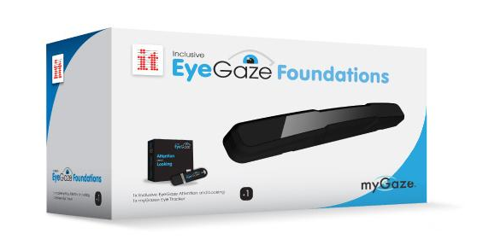

Now an easy to use myGaze eyetracker with specially designed software to use wth a range of learners is available for under £1,000. That is what I call progress

My own interest has now turned to what we can learn from what children look at when using eye-gaze. From the late 1800s eye tracking has been used to help us better understand the relationship between vision and cognition. Although we still cannot infer exactly what someone is thinking from what they are looking at — e.g. gazing on a face in a picture may indicate recognition, puzzlement, or something else — there is much we can learn from using a tool that objectively records looking behaviours. Further use and research using eye-gaze may help us better under­stand how our special needs leaners learn and hence how we can best teach and interact with them.

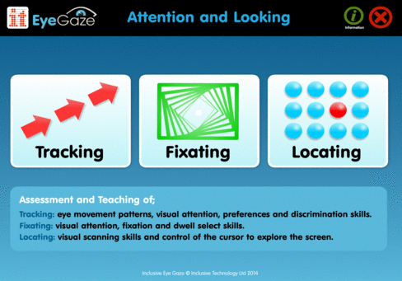

Inclusive EyeGaze Learning Curve includes powerful, easy to use analysis tools allowing you to record and review eye-gaze skills

Having followed and participated in the eye-gaze revo­lution for over 20 years I now have a ‘vision’ that eye-gaze technology will take its place alongside switch and touch technologies as an essential tool for the special needs classroom or individual. I also believe it will offer us more insights about and opportunities for our most complex students.

[***Click here***](https://www.youtube.com/watch?v=eCXkYYWLgsk&list=UUKJlb9_bMFF-pFok6l9Y8Tg) ***to watch the video of Inclusive Eye Gaze Attention and Looking***

**20+ years later … a device that can read my eyes**

As for David, I have been following his evolution too — into a handsome young man of 30 (eek!). His mum contacted me again this year (though I must say I had some lovely Xmas cards and photos in-between) to ask what I knew about eye-gaze technology. Some time later I watched him, relaxing in his recliner buggy, effortlessly using his eyes to play a game of smashing bottles. Around him other peo­ple’s eyes, mine included, were fighting back the tears. 

David and his puppy, Molly

*About myGaze:*

**The first easy eye gaze for all levels of abilities.**

**For supported and independent gaze users**

The new software provides pupils who advance in their eye gaze skills with independent access options such as the new Access Button and Gaze at Camera. They can now even start programs on their own with the help of a Double-Click. Meanwhile teachers preserve their subtle control and the ability to support the less skilled users with the help of functions such as the mouse-over-gaze precedence, profile settings and the keyboard shortcuts.  
**Communicate & participate in and outside of the classroom**

The new Play is suited not only for various levels of abilities but also for all school activities. The myGaze Grid 2 bundle will now be available from resellers in addition to a growing variety of bundles with popular classroom software for learning, leisure and choice making activities.   
Find out [more](http://www.mygaze.com/products/mygaze-assistive/) here or ask your reseller.  
**Colors and sounds make calibration fun**The child can choose different shapes and colors for the calibration point, and even their own images! Sound effect is also available to help capture the attention of not-so-easily-impressed young gaze users.

There are other additions to the new EyeMouse Play such as Dwell, Blink or Switch, Monocular & Binocular tracking, Auto-run [and more](http://www.mygaze.com/products/mygaze-assistive/).

|  |
| --- |
| https://gallery.mailchimp.com/71cbf213a591eed084236ae45/images/84f7d614-1de4-404f-9b33-e59ab44c0292.png *Image 1: Access Menu* |

|  |
| --- |
| https://gallery.mailchimp.com/71cbf213a591eed084236ae45/images/9baa7d4b-0b34-411b-8416-a2d28353dc90.png  *Image 2: Calibration Menu* |